Why do I need to do a PIA?
Section 69 (5) of the Freedom of Information and Protection of Privacy Act (FOIPPA) requires the head of a ministry to conduct a privacy impact assessment (PIA) in accordance with the directions of the minister responsible for FOIPPA. Section 69 (5.1) requires the head to submit the PIA to the minister responsible for FOIPPA for review, during the development of any new system, project, program or activity, or proposed enactment, or when making changes to an existing one. The Privacy, Compliance and Training Branch (PCT) is the representative of the Minister for these purposes. Ministries must submit PIAs to PCT at pia.intake@gov.bc.ca for review and comment prior to implementation of any initiative. If you have any questions, please call the Privacy and Access Helpline (250 356-1851) for a privacy advisor. Please see our PIA Guidelines for question-specific guidance on completing a PIA.
What if my initiative does not include personal information?
Ministries still need to complete Part 1 of the PIA and submit it, along with the signatures pages, to PCT even if it is thought that no personal information is involved. This ensures that the initiative has been accurately assessed.

Part 1 – General

Name of Ministry: | FLNRO
PIA Drafter: | Joanna Wand
Email: | Joanna.wand@gov.bc.ca | Phone: |  | 250-318-2592
Program Manager: | Robert Warner
Email: | Robert.warner@gov.bc.ca | Phone: | 250-462-8887

In the following questions, delete the descriptive text and replace it with your own.

- Description of the Initiative

The Predictive Services Agile Team was created to develop of products related to wildfire Prevention, Preparedness, Response and Recovery (PPRR) operational requirements. The team will focus on the development, implementation and delivery of tools, products and intelligence related to predictive services in the PPRR spectrum.

The Wildfire Predictive Services Web Application (the Web Application) is on online platform that will host multiple products developed by the Predictive Services Agile Team. Most products will be for internal use within BCWS and will require authentication using IDIR accounts through Keycloak. Currently there is one product that is available both internally and externally for the Community Resiliency Investment program. This application does not ask for any user identification data.

This section should provide a general description of the initiative and the context in which it functions. This could include the purpose of the initiative, its benefits, the larger process (if any) that it is part of, how it functions, the parties involved, etc. For example, the Ministry may want to overhaul its citizen engagement processes to better align with Government 2.0, or a program is moving forward because its initiative was announced in the Throne Speech.

- Scope of this PIA
This PIA concerns the Web Application. Most tools within the Web Application will require user authentication by verifying IDIR accounts with Keycloak. The Web Application will not require the user to give additional personal details.

This section should explain, where applicable, exactly what part or phase of the initiative the PIA covers and, where necessary for clarity, what it does not cover. For example, if a Ministry is overhauling its citizen engagement process to better align with Government 2.0 and is launching new website features, this particular PIA may only be about the Ministry’s new blog. This blog would then be the “scope” of the PIA. This section may also describe what phase of the initiative this PIA covers.
- Related Privacy Impact Assessments
There are no current or previous PIAs related to this initiative.

This section should identify, where applicable, PIAs for other parts of the initiative or any PIAs that were previously completed for this initiative. To follow on from the above example, this section may cite a PIA that has already been completed on the Ministry’s website or on the video site that the new blog will sometimes link to.
- Elements of Information or Data
The Web Application requires the user to log in with an IDIR account.

Please list the elements of information or data involved in the initiative. This could include client’s name, age, address, work/home email, work/home phone number, educational history, employment history, work status, health information, financial information, photos, comments on a blog, or information specific to your subject area, like stumpage totals, fish license numbers, visitor centre stats, or hiring data.

Part 2 – Protection of Personal Information
If no personal information is involved, please submit Parts 1, 6, and 7 unsigned to PCT at pia.intake@gov.bc.ca. A privacy advisor will be assigned to your file and will guide you through the completion of your PIA.
If personal information is involved in your initiative, please continue to the next page to complete your PIA.

In the following questions, delete the descriptive text and replace it with your own.

- Storage or Access outside Canada
Please provide a brief description of whether your information can be accessed from outside Canada, for example, by a service provider that is repairing a system, or if your information is being stored outside Canada, for example, in the “cloud”. If your data is stored within Canada and accessible only within Canada, please indicate this.
- Data-linking Initiative*

In FOIPPA, "data linking" and “data-linking initiative” are strictly defined. Answer the following questions to determine whether your initiative qualifies as a “data-linking initiative” under the Act. If you answer “yes” to all 3 questions, your initiative may be a data linking initiative. If so, you will need to comply with specific requirements under the Act related to data-linking initiatives.
- Personal information from one database is linked or combined with personal information from another database; | yes/no
- The purpose for the linkage is different from those for which the personal information in each database was originally obtained or compiled; | yes/no
- The data linking is occurring between either (1) two or more public bodies or (2) one or more public bodies and one or more agencies. | yes/no
If you have answered “yes” to all three questions, please contact a PCT Privacy Advisor to discuss the requirements of a data-linking initiative.

- Common or Integrated Program or Activity*

In FOIPPA, “common or integrated program or activity” is strictly defined. Answer the following questions to determine whether your initiative qualifies as “a common or integrated program or activity” under the Act. If you answer “yes” to all 3 of these questions, you must comply with requirements under the Act for common or integrated programs and activities.
- This initiative involves a program or activity that provides a service (or services); | yes/no
- Those services are provided through:  (a) a public body and at least one other public body or agency working collaboratively to provide that service; or  (b) one public body working on behalf of one or more other public bodies or agencies; | yes/no
- The common or integrated program/activity is confirmed by written documentation that meets the requirements set out in the FOIPP regulation. | yes/no
Please check this box if this program involves a common or integrated program or activity based on your answers to the three questions above.

* Please note: If your initiative involves a “data-linking initiative” or a “common or integrated program or activity”, consultation on this PIA must take place with the Office of the Information and Privacy Commissioner (OIPC). PCT will facilitate the consultation with the OIPC.

For future reference, ministries are required to notify the OIPC of a” data-linking initiative” or a “common or integrated program or activity” in the early stages of developing the initiative, program or activity. PCT will help facilitate this notification.

- Personal Information Flow Diagram and/or Personal Information Flow Table
Please provide a diagram and/or table that shows how your initiative will collect, use, and/or disclose personal information (see examples below). Your diagram and/or table must also include the authorities for the collection, use, and disclosure of personal information, as laid out in FOIPPA. It should also outline the flows of personal information wherever it is transmitted or exchanged.
Both a flow diagram and a table must be included if the PIA is related to a common or integrated program or activity or a data-linking initiative.
For ease of reference, the collection, use, and disclosure authorities in FOIPPA can be found in the appendices. If you do not know what the relevant authorities are, please contact a PCT privacy advisor.
Depending on the complexity of your initiative, you may choose to provide one general diagram for the initiative, and more specific diagrams for particular components. If multiple organizations will collect, use, or disclose personal information, the diagram should identify how each organization is involved in the initiative.
Example:

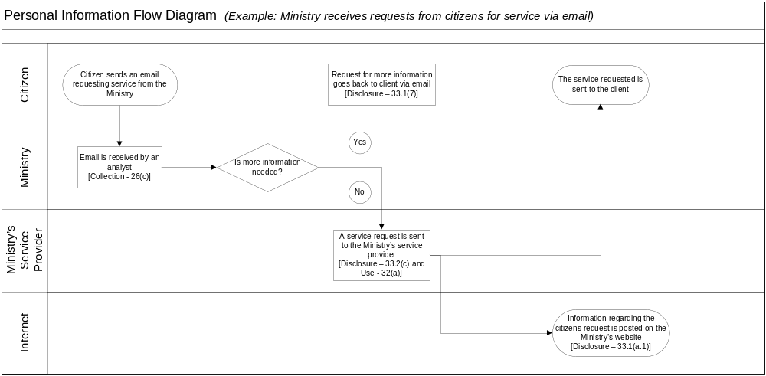
Examples can be removed and additional lines added as needed.
Personal Information Flow Table
 | Description/Purpose | Type | FOIPPA Authority
1. | Email received from client requesting service | Collection | 26(c)
2. | Email client back requesting more information | Disclosure | 33.1(7)
3. | Service request transferred to service provider contracted by Ministry | Disclosure & Use | 33.2(c) and 32(a)

- Risk Mitigation Table
Please identify any privacy risks associated with the initiative and the mitigation strategies that will be implemented. Please provide details of all such strategies. Also, please identify the likelihood (low, medium, or high) of this risk happening and the degree of impact it would have on individuals if it occurred.
Examples can be removed and additional lines added as needed.
Risk Mitigation Table
 | Risk | Mitigation Strategy | Likelihood | Impact
1. | Employees could access personal information and use or disclose it for personal purposes | Role-based access | Low | High
2. | Request may not actually be from client (i.e. their email address may be being used by someone else) | Implementation of identification verification procedures | Low | High
3. | Client’s personal information is compromised when transferred to the service provider | Transmission is encrypted and over a secure line | Low | High
4. | Inherent risks in sending personal information to a client via email | Policy developed to inform clients of risk and ask if they would like the information via a different medium, such as through the mail | Medium | Medium

- Collection Notice
If your initiative is collecting personal information directly from individuals you must ensure that all individuals involved are told the following:
- The purpose for which the information is being collected
- The legal authority for collecting it, and
- The title, business address and business telephone number of an officer or employee who can answer questions about the collection.
Please include your proposed wording for a collection notice and where it will be located for individuals to read before collection takes place. You can also attach a screen shot or a copy of your form where the collection notice would be located. For further help with collection notices please see the “Collection Notice Tip Sheet” located on the CIO’s website.
Part 3 – Security of Personal Information
If this PIA involves an information system, or if it is otherwise deemed necessary to do so, please consult with your Ministry Information Security Officer (MISO) when filling out this section. Your MISO will also be able to tell you whether you will need to complete a separate assessment called a Security Threat and Risk Assessment (STRA) for this initiative.

- Please describe the physical security measures related to the initiative (if applicable).
For example: locked cabinets, securely stored laptops, or key card access to the building.
- Please describe the technical security measures related to the initiative (if applicable).
For example: use of government firewalls, document encryption, or user access profiles assigned on a need-to-know basis.
- Does your branch rely on security policies other than the Information Security Policy?
Please describe any specific policies and procedures and provide contact details for someone who could answer further questions regarding these policies and procedures.
- Please describe any access controls and/or ways in which you will limit or restrict unauthorized changes (such as additions or deletions) to personal information.
For example: role-based access.
- Please describe how you track who has access to the personal information.
For example: audit trails or physical sign-in and sign-out of files.

Part 4 – Accuracy/Correction/Retention of Personal Information

- How is an individual’s information updated or corrected? If information is not updated or corrected (for physical, procedural or other reasons) please explain how it will be annotated? If personal information will be disclosed to others, how will the ministry notify them of the update, correction or annotation?
For example: users have access to update their own information or, notes will be made on a government case file.
- Does your initiative use personal information to make decisions that directly affect an individual(s)? If yes, please explain.

- If you answered “yes” to question 17, please explain the efforts that will be made to ensure that the personal information is accurate and complete.
For example: check to see that the information was obtained from a reputable source such as another government agency.
- If you answered “yes” to question 17, do you have approved records retention and disposition schedule that will ensure that personal information is kept for at least one year after it is used in making a decision directly affecting an individual?
If you do not have a schedule, please document how these records will be kept until a schedule is in place. Please describe retention schedules that apply where retention exceeds the one year requirement of the FOIPPA. Please contact your Ministry Records Officer if you need assistance.

Part 5 – Further Information

- Does the initiative involve systematic disclosures of personal information? If yes, please explain.
For example: your ministry has a regular exchange of personal information (both collection and disclosure) with the federal government in order to provide services to your ministry’s clients. Under section 69 (2), this information is required to be published in the Personal Information Directory (PID), which is maintained and published by PCT.

Please check this box if the related Information Sharing Agreement (ISA) has been prepared. If you have general questions about preparing an ISA, please contact the Privacy and Access Helpline.

If an ISA has been prepared as part of your initiative, please complete the fields in the table below by deleting the descriptive text in the right-hand column and replacing it with your own.

Information Sharing Agreement – Required Information
Description | A regular exchange of personal information between the Ministry of Administration (MADMIN) and the University of Life in order to provide scholarships to eligible residents of BC.
Primary ministry/government agency involved | MADMIN
All other ministries/government agencies and public bodies involved | University of Life
Business contact title | Manager, Administration Services
Business contact telephone number | 250-555-5555
Indication of whether or not personal information is involved | Yes
Start date | 26-Apr-14
End date (if applicable) | 28-Apr-15

- Does the program involve access to personally identifiable information for research or statistical purposes? If yes, please explain.
For example: you will be disclosing information to PhD students so they can conduct research.
Please check this box if the related Research Agreement (RA) is attached. If you require assistance completing an RA please contact a PCT advisor.

- Will a personal information bank (PIB) result from this initiative?
A personal information bank means a collection of personal information that is organized or retrievable by the name of an individual or by an identifying number, symbol, or other particular assigned to an individual. Under section 69 (2) of FOIPPA, this information is required to be published in the PID, which is maintained and published by PCT.
If yes, please complete the fields in the table below by deleting the descriptive text in the right-hand column and replacing it with your own.

Personal Information Bank – Required Information
Description | Personal contact information of branch staff in case of emergency
Primary ministry/government agency involved | MADMIN
All other ministries/government agencies and public bodies involved | None
Business contact title | Office Manager, Administration Services
Business contact telephone number | 250-555-5555

Please ensure Parts 6 and 7 are attached unsigned to your submitted PIA.

Part 6 – PCT Comments and Signatures
This PIA is based on a review of the material provided to PCT as of the date below. If, in future any substantive changes are made to the scope of this PIA, the ministry will have to complete a PIA Update and submit it to PCT.

Privacy Advisor  Privacy, Compliance and Training Branch  Ministry of Finance |  | Signature |  | Date
Director or Manager  Privacy, Compliance and Training Branch  Corporate Information and Records Management Office Ministry of Finance (if Personal Information is involved in this initiative) |  | Signature |  | Date

Part 7 – Program Area Comments and Signatures

Program Manager |  | Signature |  | Date
Ministry Contact Responsible for Security (Signature not required unless MISO has been involved.) |  | Signature |  | Date
Assistant Deputy Minister or Designate (if Personal Information is involved in this initiative) |  | Signature |  | Date
Executive Director or equivalent (if no Personal Information is involved in this initiative) |  | Signature |  | Date

A final copy of this PIA (with all applicable signatures and attachments) must be provided to PCT for its records to complete the process. PCT is the designated office of primary responsibility for PIAs under ARCS 293-60.

PCT will publish the ministry name, business contact details and a brief summary of the PIA to the Personal Information Directory (PID) as required by section 69(2) of FOIPPA. If you have any questions, please contact your privacy advisor at PCT or call the Privacy and Access Helpline at 250 356-1851.

